**Detect Shake Gestures Widget**

**Installation**

1. Copy **com.temenos.widgets.hybrid.accelerometer.detectGestures** folder in your widgets folder (Ex: /{your project/templates })
2. Copy the content of **Insert in widget.xml** in your widget.xml file within your project
3. Make sure the **cordova_loader.js** file is inserted in your template header for the phase where you want to use the **Detect Shake Gestures Button** widget.

Insert ***<script src="$$HTML_LOCATION$/js/cordova/cordova_loader.js"></script>*** in your header TPL.

**How to use**

1. You will have to add a new custom button in your presentation.Within **Appereance** -> **Button tab** for ”Display Type” field you have to select “Detect Shake gestures“
2. Within Widget Details tab you have to set up the widget settings .

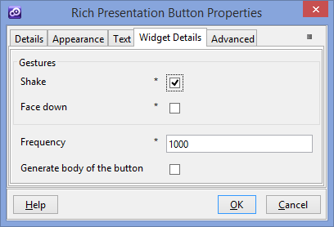

* **Shake -**  Enable/Disable shake gesture detection
* **Face down** – Enable/Disable face down gesture detection
* **Frequency** - How often to retrieve the Acceleration in milliseconds. It’s recommended to use same value for the frequency for each widget instance within your phase.
* **Generate body of button** – Enable / Disable the generation to the body of the button.

You could find more technical details on cordova website 🡪 http://cordova.apache.org/docs/en/3.1.0/cordova_accelerometer_accelerometer.md.html